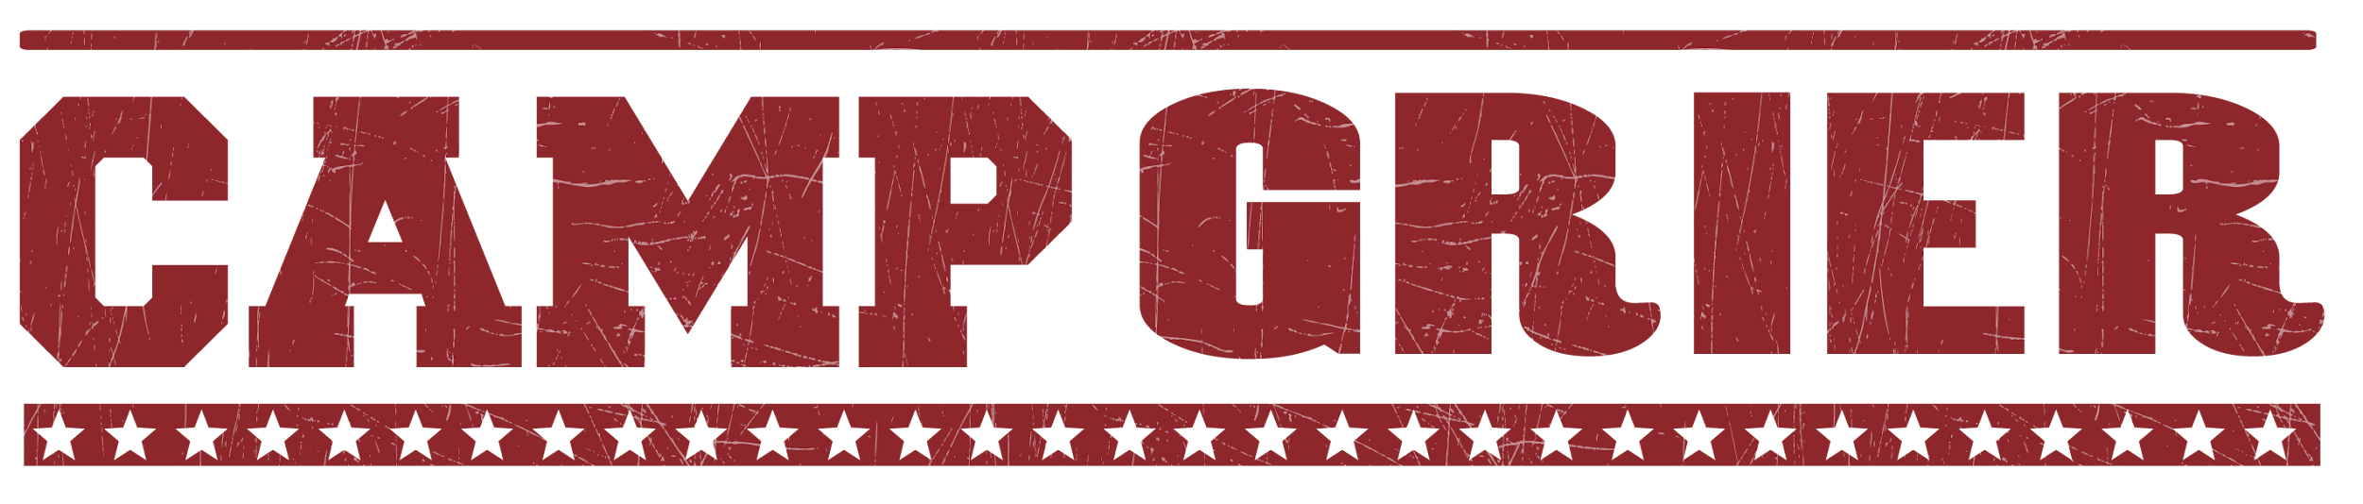
CAMPER PACKING LIST
Please do NOT bring:
Cell Phones or Electronics
Candy or Gum
Food
Weapons of any kind
Non-prescription drugs
- Daypack (bookbag)
- Flashlight or headlamp
- BUG SPRAY!!!
- Sunscreen
- 2 Water Bottles
- Bedding
  - Sleeping Bag
  - Blanket/Sheets for single bed
  - Pillow
- Laundry bag
- Toiletries
  - 2-3 Towels
  - Washcloth
  - Toothbrush, toothpaste, etc.
  - Soap, shampoo, etc .
  - Deodorant
- Pajamas
- Outdoor clothes that are comfortable and can get dirty!
  - Quick dry shirts, t-shirts, tanks
  - Shorts
  - Pants
  - Appropriate Swimwear
  - Sweater and/or warm jacket (it can get chilly in the evenings)
  - Rain gear (Rain jacket or poncho)
  - Baseball hat, possibly a winter hat
- Footwear
  - Tennis shoes
  - Water shoes that can get wet (must have a backstrap)
  - Sturdy hiking shoes
  - Socks (can never have too many) including a heavy pair for hiking
  - Shower shoes (Flip flops are not allowed outside of the cabin)
- Stationary & Stamps for those who love writing letters!
- Journal, pen and pencil
- Optional: Hammocks
Costumes/accessories for Rustic Dance (Adventurer & Navigator)
Small Fan (if battery powered, bring extra batteries)

Specialty camps:
We provide bikes and helmets (both for MTB and equestrian, NOT OneWheel).
You are welcome to bring your own if you prefer.

Navigator Wilderness Camp:
Camp Grier can provide PFD’s, hiking backpacks, sleeping bags and sleeping pads. Campers are welcome to bring any personal gear if they prefer. Activities may include: paddling, backpacking and/or rock climbing.
Suggested items include:

- Hiking Backpack
- Hydration Pack
- Hiking boots
- Climbing Shoes
- Crazy Creek
- Sleeping pad
- Flashlight/headlamp
- Layers for all weather conditions

Mountain Bike specialty list:
Camp Grier has a fleet of full suspension bikes and all necessary equipment for campers to use. Campers are welcome to bring personal riding gear if they prefer.

Gear
- Bike in good working order
- Lightweight athletic shirt(s)
- Shorts
- Skate shoes or biking shoes,
- Water bottle or backpack to carry water on rides
Safety
- Helmet
- Sunglasses, Goggles, Or safety glasses

Equestrian specialty list:
- Long pants or jeans (preferably cotton or a material that provides some grip)
- Long socks
- Boots or shoes with a heel (sturdy and water resistant if possible)
- Bug spray!!!
- Riding helmet (we provide helmets, however sizes may be limited)

OneWheel specialty list:
Safety
- Long Pants
- Helmet
- Knee pads
- Wrist guards
- Sunglasses, Goggles, Or safety glasses
Gear
- Onewheel(s)
- Charger(s)
- Anything they need to ride comfortably
- Skate shoes

